Report

Muhammad Omais Rana
Master’s 1 IoT – UFR STGI

General Understanding:
At the physical layer, LoRa utilizes mathematically orthogonal Spreading Factors (SF) to allow multiple devices to transmit on the exact same frequency simultaneously without interference, assigning higher SFs to more distant devices to compensate for path loss and ensure the signal reaches the gateway. However, at the MAC layer, this extended range incurs a significant Time-on-Air penalty. Because LoRaWAN relies on an uncoordinated ALOHA protocol where devices transmit asynchronously, the much longer transmission times associated with those higher SFs drastically increase the probability of collisions in the air, which ultimately degrades the network's overall Packet Delivery Ratio.
Answer to the question:
LoRaWAN can allow multiple devices to transmit simultaneously on the same frequency because different Spreading Factors are mathematically orthogonal. This means their cross-correlation is nearly zero. The gateway's receiver can filter out signals on SF8 as background noise while actively decoding an SF7 signal on the exact same channel.
Screenshots:
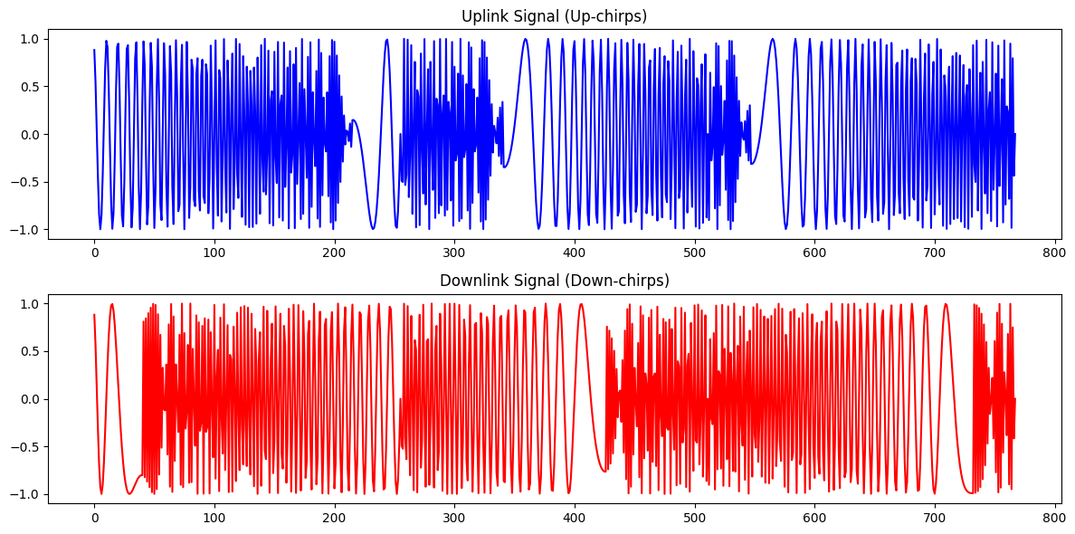
Figure 1 Task 1.1

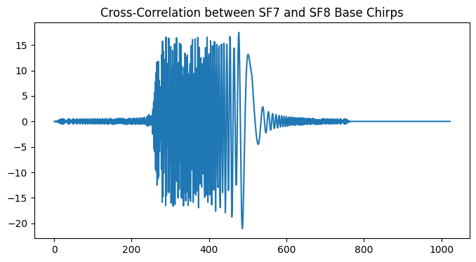
Figure 2 Task 1.2

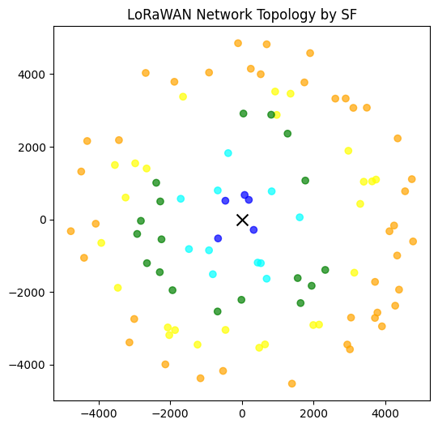
Figure 3 Task 2.1 & 2.2 with ToA for 20 bytes at SF10: 329.73 ms
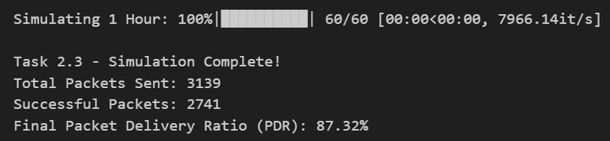
Figure 4 Task 2.3

